## 7. UAVG Compliance for Log360

Tagline – Simplify UAVG compliance with automated log analysis and audit reporting using Log360.

Overview: The UAVG Compliance extension for Log360 helps organizations align with UAVG requirements and standards. By integrating this extension, IT and security teams gain comprehensive visibility into their compliance posture across all critical controls.
Log360 continuously collects and correlates log data from Active Directory, Windows, Unix/Linux, Microsoft 365, cloud platforms, and network devices, mapping events directly to UAVG requirements. Security teams can track compliance status in real time, investigate incidents quickly, and generate audit-ready reports with a single click.

Key Features:
- Generate comprehensive audit-reports mapped to all UAVG controls and compliance requirements.
- Automatically parses and normalizes log formats from Windows, Linux, firewalls, databases, and cloud platforms for consistent analysis.
- Generates real-time alerts for defined events, rule violations, and anomalies with multi-channel notifications.
- Export reports in PDF and CSV format for auditors, management, or regulatory submissions.

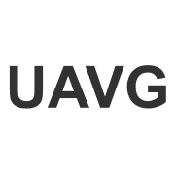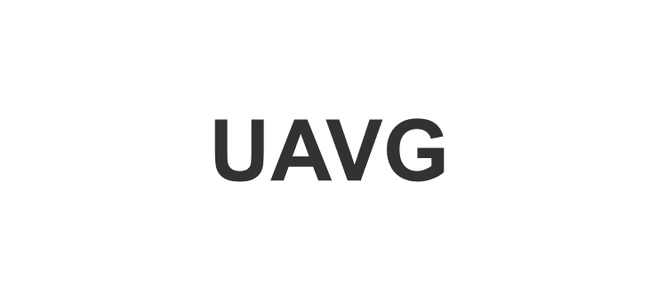
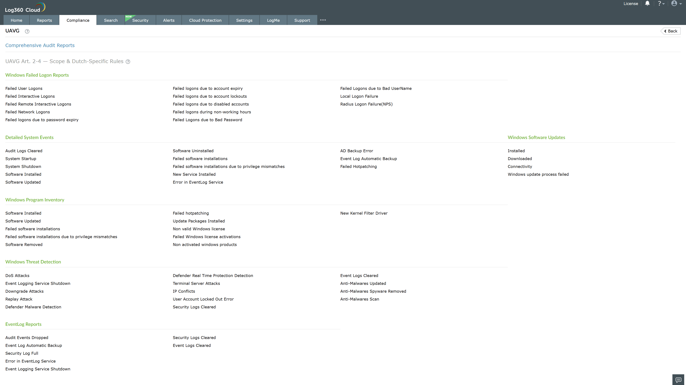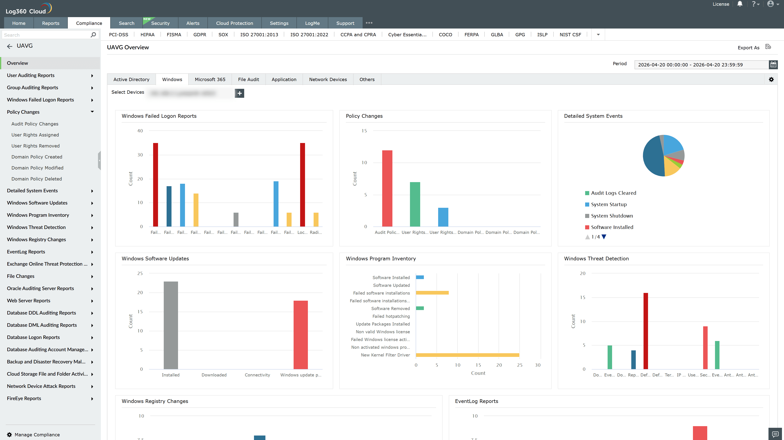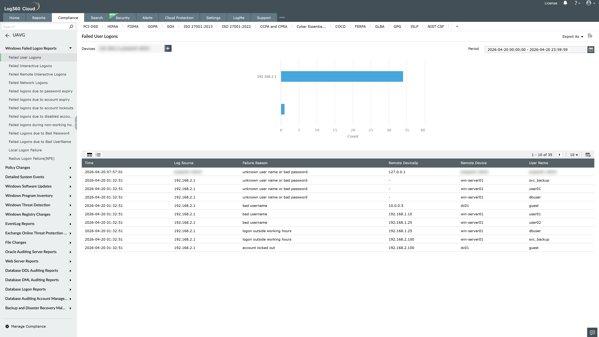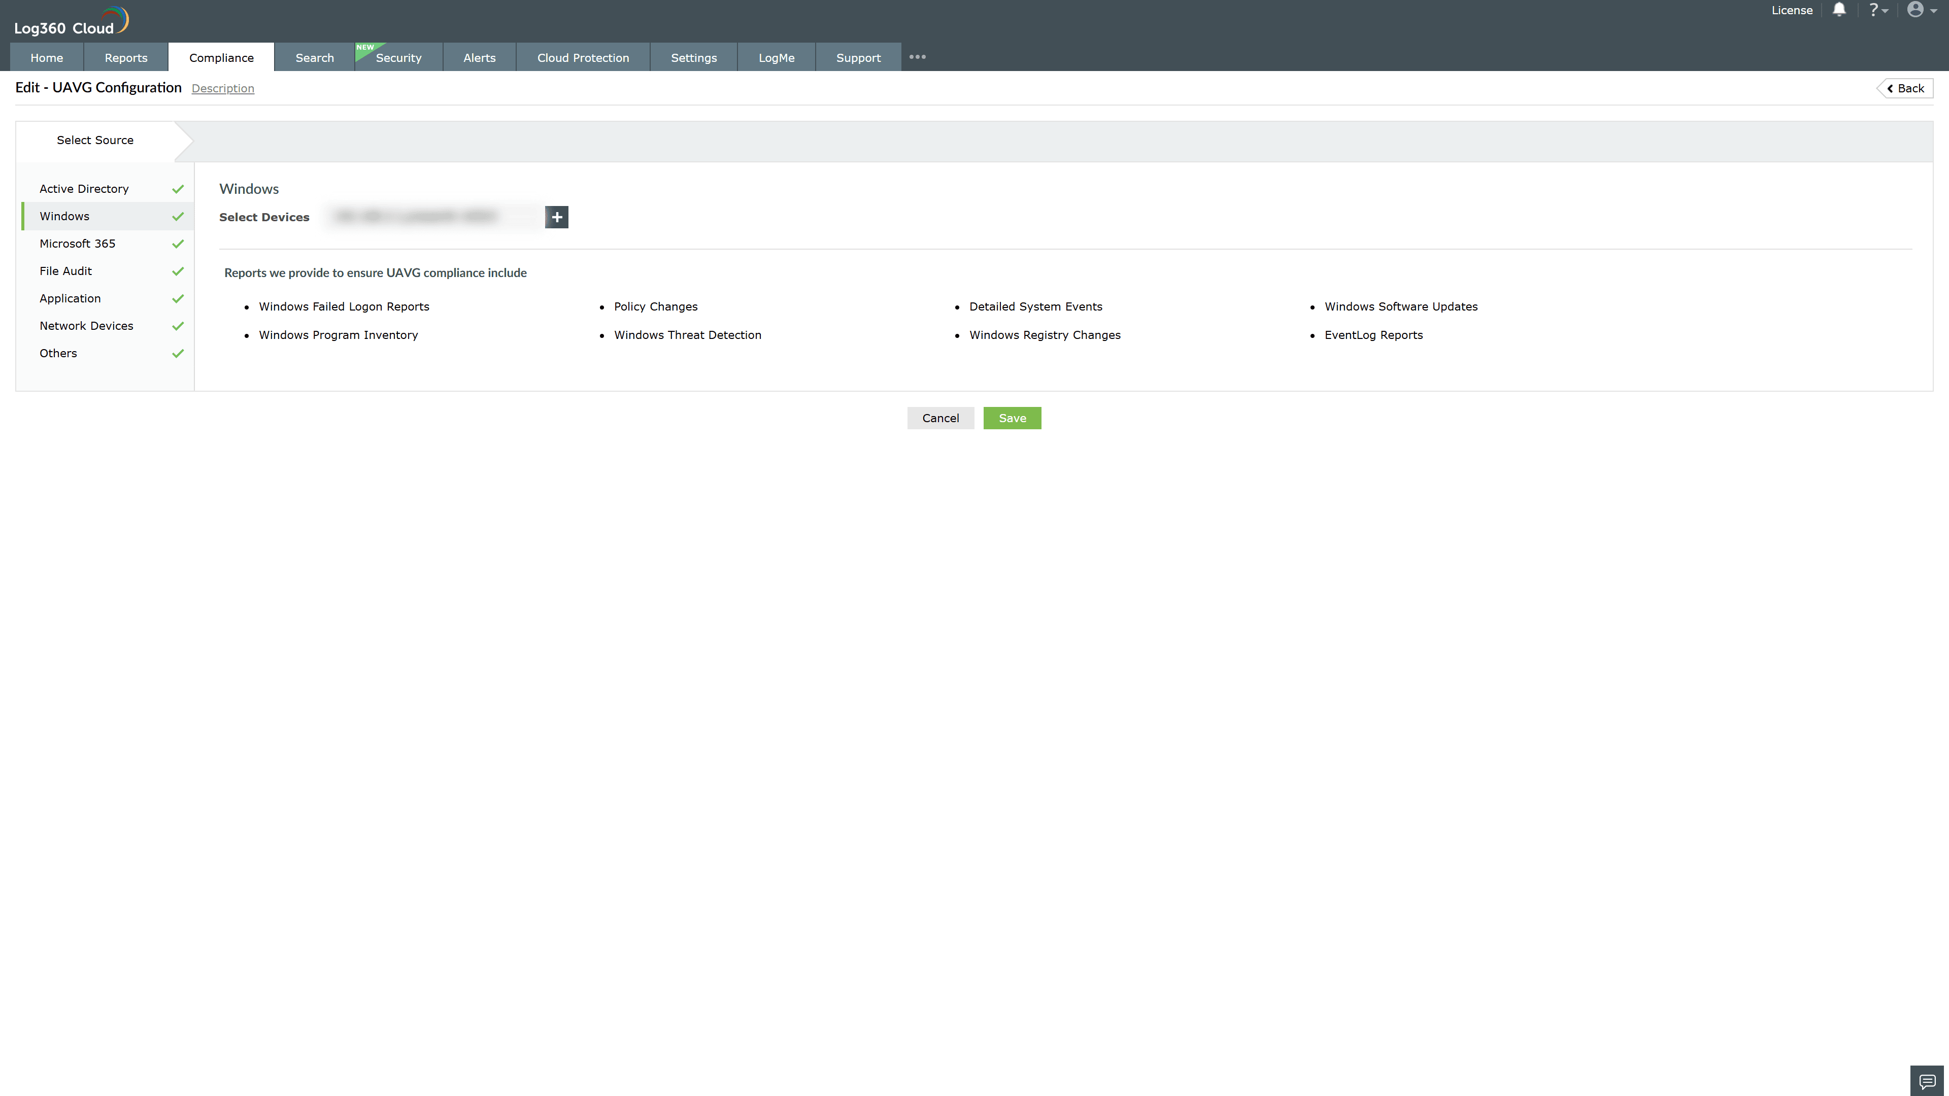
Valid Submission : Yes
Supported Editions : Free, Basic, Standard, Professional, MSSP
Help Document : https://www.manageengine.com/log-management/help/integrations/compliance-extensions.html
Help Video : Not provided
Tags : Log360, Compliance, Privacy monitoring, Data privacy, Regulatory compliance
Supported DCs : US, IN, JP, CA, AU, UK and EU
Privacy Policy:
Terms of Service:
Release Notes:
Predefined reports for the UAVG Compliance.

